DRAFT SAMPLE EXAMINATION

MARKING KEY

2008/17059[v3]0000.doc

SECTION ONE—SHORT RESPONSE

Question 1

Description | Marks
Correctly indicates break-even point, profit and margin of safety | 4-5
Correctly indicates break-even point | 3
Correctly indicates sales and costs on break-even chart | 1-2

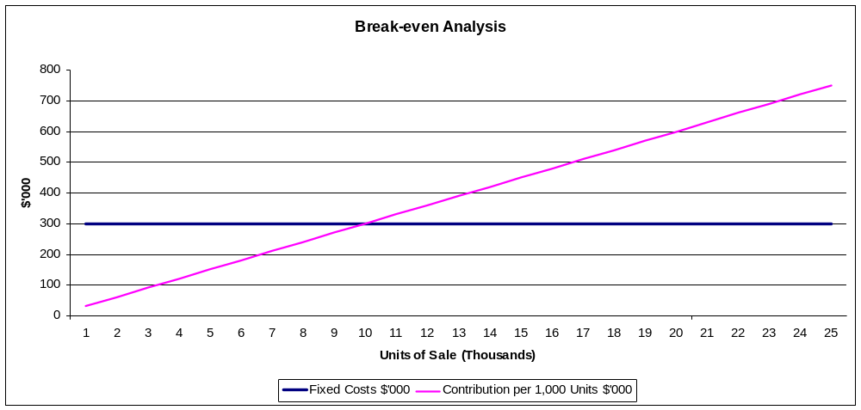

Break-even point: 10 000 units
Profit at forecast output: $300 000
Margin of safety at forecast output: 10 000 units

Description | Marks
Defines break even, fixed costs, variable costs and purpose of break even analysis to explain effect on break-even point of changing variable costs | 4-5
Uses general principles underlying break-even to determine and discuss effect on break-even point | 3
Uses chart as required, indicating effect of changed costs | 1-2

Break-even point changes to 12 000 units.
The contribution per unit decreases to $25, therefore the number of units required to cover fixed costs increases.
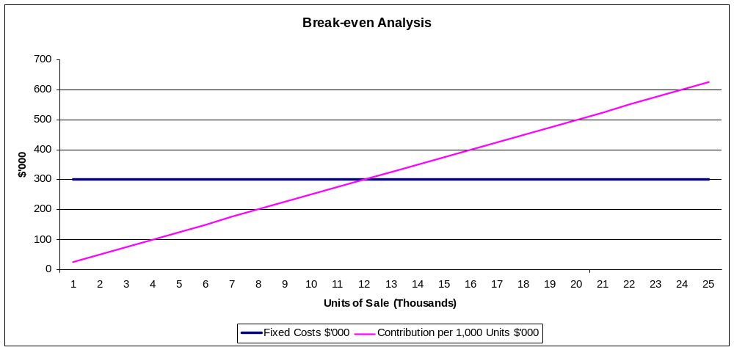
Question 2

Description | Marks
Liquidity is poor and getting worse (1.36:1 in 2006; 1.03:1 in 2007). From a business perspective this is a concern although it is not a major issue for another business purchasing Juicy Fruit. | 1
Profitability is consistent with industry averages (NP ratio 6.9% in 2006 and 5.38% in 2007). | 1
Efficiency: the expense ratio of 18.18% in 2006 and 18.46% in 2007 is similar to industry norms. | 1
Solvency as indicated by the debt to equity is very poor and getting worse (483% in 2006 and 677% in 2007). This is a major concern as the level of external debt is very high, making the business vulnerable to the demands of creditors. If the assets were to be valued at their sale value in an insolvency situation the total asset value could be entirely different to that indicated on the balance sheet where they are part of a going concern. | 3
A further matter for concern is that the owners have undertaken significant profit taking, withdrawing nearly all of net profit for both years and thus weakening the liquidity and solvency positions. | 1
The business may be a sound acquisition if the price is right. The balance sheet does not indicate any value for goodwill which is probably fair. | 1
Total | 8

Description | Marks
Although profitability is adequate the poor liquidity and solvency positions indicate poor management and a new management team would be needed. | 2
Total | 2

Question 3

Description | Marks
Any two appropriate factors.  Answers could include:  language,  religion,  tastes,  social class,  dietary preferences. | 1 mark each, max 2

Description | Marks
Any appropriate response.  Answers could include:  competitor profiling  barriers to entry  distribution structures  demographics | 1 mark each, max 2

Description | Marks
Any appropriate global financial influence explained.  Answers could include  currency fluctuations,  interest rate changes and differences, and  the ability of the business to borrow overseas. | Any 1 item.  1 mark for item, 1 for explanation

Description | Marks
Any two appropriate legal considerations.  Answers could include:  employment relations  processes for dispute resolution;  regulation of food quality and health and safety controls;  protection of brand name,  intellectual property,  assets,  web addresses,  know-how;  confidentiality agreements;  compliance with government sanctions and regulations; | 1 mark each, max 2

Description | Marks
Any appropriate responses.  Answers could include:  automated production systems could reduce contamination of food by human contact  Instant electronic communication with management automatically triggered in the event that error occurs  Tracking of ingredients and inventory of finished products | 1 mark for item, 1 for explanation

Question 4

Description | Marks
Any two appropriate decisions.  Answers could include  decisions about facility layout and design such as introducing a functional layout, where work components are arranged together according to similarity of function. By grouping functions together appropriate measures could be taken at each stage to ensure that there are fewer accidents and injuries.  or  effective management of materials by adopting a ‘just in time’ materials management program. The materials will arrive just as they are needed, which will improve operations as they will not have to store and manage excess stock levels. Given that the materials can be dangerous, this will reduce the possibility of accidents occurring when storing the materials.  or  use of technology, such as robotics to reduce human handling of material | 1 mark each for 2 decisions, 1 mark each for explanation, max 4

Description | Marks
The elements of an operations management system are inputs, processes and outputs. Inputs are the raw materials the organisation uses to create its product or service. These might include knowledge and skills, human resources and materials.  An appropriate example must be given. | 1 for explanation, 1 for example
Processes are the transformation stage that turns the inputs into outputs.  An appropriate example must be given. | 1 for explanation, 1 for example
Outputs are the finished product or service that is offered to customers.  An appropriate example must be given. | 1 for explanation, 1 for example
Total | 6

Question 5

Description | Marks
Corporate social responsibility is the continuing commitment by business to behave ethically and contribute to economic development while improving the quality of life of the workforce, their families and the local community and society at large.  Corporate responsibility is achieved when a business adapts all of its practices to ensure that it operates in ways that meet, or exceed, the ethical, legal, commercial and public expectations that society has of business.  Triple Bottom Line (TBL) reporting focuses on reporting of an organisation's economic, environmental and social performance.  As such, TBL can be seen as both as an internal management tool, and an external reporting framework. | 1  1  1  1
Total | 4

Description | Marks
Any 6 appropriate strategies.  Answers could include  public awareness campaign involving local meetings, local newspaper advertising and advertorials,  investing in community through development of public parks  market the employment opportunities, career pathways and training and development which will benefit the community  engage environmental scientists to investigate the environmental impact and add expert opinions to the discussion  consider how the facility might be re-designed to reduce damaging emissions  using technology to reduce environmental impact and demonstrate CSR by engaging with experts on ways of minimizing impact  introducing repair and regeneration programs to the river system | 1 mark each, max 6

Question 6

Description | Marks
An appropriate change management theory is Lewin’s change model. Lewin’s first step is to unfreeze the present pattern of behaviour. This has the aim of unblocking the present system through some kind of confrontation and retraining to deal with resistance to change, and may involve promoting or terminating employees and developing training programs in new areas. At Joe’s Shirt Shack the latter is a key element that would be required to implement new policies.  The second step involves movement, such as making the actual changes. At Joe’s Shirt Shack there will be new policies, new management practices and new reward systems and conditions for employees.  The final step is refreezing, which involves stabilising or institutionalising the changes made. At Joe’s Shirt Shack this may involve changing recruitment practices and establishing measures to ensure the new practices are being followed appropriately. | 2  1  1
Total | 4

Description | Marks
Elements of the external environment that would have pressured Joe’s Shirt Shack to change are social pressures and changes in community attitudes. Customers have a much higher awareness of organisational behaviour and are placing demands on them to behave in a socially responsible manner. Increasingly, customers are basing their purchasing decisions on factors other than purely financial reasoning.  The legislative environment is another element of the external environment that has placed pressure on Joe’s Shirt Shack. Parliaments are passing many laws relating to industrial relations and businesses are expected to meet those minimum or award conditions for their employees. | 1  1
Total | 2

Description | Marks
Financial key performance indicators such as profitability, turnover  Non-financial key performance indicators such as employee satisfaction levels, staff turnover, on-time completion, customer satisfaction level surveys. | 1  1
Total | 2

Description | Marks
The answer depends on what was given above in c). An example could be that profitability, as a financial KPI, could be used to benchmark progress and the success of changes in Joe’s Shirt Shack’s performance as it reflects the number of sales and efficiency of operations over a set period of time. | 1
A non-financial KPI such as an employee satisfaction survey could be used to improve performance as it alerts management that aspects such as the relationship with employees, is below expectations. Unhappy employees are likely to be less productive and to produce a product of inferior quality. If employee satisfaction levels have not improved over a period of time management would need to implement further steps to improve performance. | 1
Total | 2

Question 7

Description | Marks
Many firms sell on credit, which is where the sale is made and the customer pays at a later date. Most businesses say that the money is earned when the sale is made, not when the business receives the cash. A business can then make a large profit and still be in trouble because it has no cash and is unable to pay its creditors. | 1  1  1
Total | 3

Description | Marks
A cash budget is a document that sets out all future cash receipts (when the business receives cash) and future cash payments (when the business pays cash out), and determines whether there is likely to be a cash shortage or a cash surplus in the future. By identifying the future cash receipts and future cash payments, management can see when cash shortages are likely to occur and plan accordingly. They may decide to spend less by postponing the purchase of non-essential items, or arrange to borrow cash from another source. | 1  1
Total | 2

Description | Marks
By reducing the cash payments for that period of time the cash flow will be improved, assuming that cash receipts remain the same. | 1

Description | Marks
Although the cash outflow would be reduced and therefore may appear to be justified for financial reasons, it may have an adverse effect on morale, interpersonal relations in the workplace, and employee motivation. It is likely to create a new human relations problem for the management. Decisions like this place managers in situations where they may have to sacrifice some values for others. Ethics involve moral principles which can affect the climate in an organisation. Loyalty to employees, and by employees to the business, is an important aspect of business management. Management should list alternatives to resolving the cash flow problems and consider the implications of each. | 1  1  1  1
Total | 4

SECTION TWO—EXTENDED RESPONSE

Question 8–Compulsory
[25 marks]

Description | Marks
The answer should be in letter format – 1 mark each for  letterhead or address in top right corner and addressee information,  salutation and subject line  close and date | 3
Structure of answer: introduction, conclusion, logical flow, business terminology and good grammar | 1–2
Provides full explanations of factors involved in producing mobile phones in China, incorporating points from the list below. Students analyse, understand, predict trends and evaluate possible risks and benefits of the proposed action and make appropriate preliminary recommendations. | 20
Provides full explanations of factors involved in producing mobile phones in China, incorporating points from the list below. Students analyse, understand and evaluate some possible risks and benefits of the proposed action and make preliminary recommendations. | 16–19
Provides explanations of factors involved in producing mobile phones in China, incorporating points from the list below. Students explain how factors can have an impact on the potential for success of the proposed action. | 11–15
Identifies factors involved in producing mobile phones in China, incorporating points from the list below. Students identify whether factors are likely to be a risk or a benefit. | 7–10
Lists some points from the list below, but does not relate them to the proposed action. | 3–6
Provides limited or inaccurate information. | 1–2

Students may include any of the following in their response:

- Economic:
  - benefits of lower manufacturing costs, could lead to higher profits
  - China is a large potential market – opportunity to grow market share, increase profits
  - Risks include expense of re-importing, including costs of transport, which could negate cost savings.
  - As China’s wealth grows, labour will become more expensive.

- Socio-cultural:
  - There are cultural differences between Australia and China that are manifest in the different languages, values and way work is performed.
  - This could interfere with communications and lead to mismatched expectations which could increase the risk to Crazy John’s.
  - For example, quality standards in China could be different from those in Australia, reducing the quality of Crazy John’s products.

- Legal considerations:
  - There are different legal frameworks in China. There would be a need to ensure understanding of local laws.
  - On the one hand this could expose the company to greater risk as corrupt practices are common in China and it also increases the risk of exploitation of labour.
  - Labour exploitation is an ethical issue which would have a very negative impact on Crazy John’s image; therefore practices in China would need to be closely monitored to ensure the company did not suffer a back lash in Australia.

- Political:
  - China is still a relatively controlled society and a change in political ideology could have negative impacts on Crazy John’s business.
  - For example, a political push to implement new laws controlling foreign enterprises or employment practices in China could have immediate impacts on Crazy John’s operations.
  - There is also the danger of limits on monies that can be taken out of China.

- Technological:
  - Technologies used in China could be copied or superseded.
  - The cost of innovation could be lower even as innovative ideas are harvested in China through the employment of Chinese graduates who are paid less than Australians.

- Target market:
  - Currently Crazy John’s customers expect to find well known brand names marketed through all the stores, as well as on line.
  - There could be a danger that customers no longer identify Crazy John’s with quality brands, but rather with ‘own brands’ which have connotations of being cheaper versions of the real thing.
  - Such a re-focussing of product offerings would need to be carefully managed to avoid confusion in the market.

- Competitive advantage:
  - Crazy John’s major competitive advantage currently comes from innovative and high quality customer service.
  - In order to maintain this competitive advantage the new phone would need to be marketed as an opportunity to get better value for money, but still enjoy a high quality product and service.
  - The company would need to consider the marketing strategies and market positioning of the new product, as well as the pricing strategy.

- Concluding statements should point out that these are preliminary findings and that further research would need to be conducted before any definitive action could be recommended.

Question 9 – do EITHER this question OR Question 10
[25 marks]

Description | Marks
Appropriate report format should be used, including  - the title (with terms of reference),  - the executive summary,  - the introduction, main body, and conclusion,  - recommendations. | 1  1  1  1
Total marks for format | 4
Grammar and spelling (including appropriate use of business terminology) | 0–2
Total for grammar and spelling | 2
Provides full explanations of each of the financing strategies, incorporating most points from the list below. Students analyse and evaluate the strategies in relation to the objectives, draw conclusions and make appropriate recommendations. | 19
Provides full explanations of each of the financing strategies, incorporating many points from the list below. Students analyse and evaluate the strategies, draw conclusions and make recommendations. | 14–18
Provides explanations of each of the financing strategies, incorporating some points from the list below. Students analyse a few strategies, draw conclusions and make recommendations. | 9–13
Provides outlines of financing strategies, incorporating some points from the list below. Students draw conclusions and make recommendations. | 5–8
Provides limited information about financing strategies. Draws a conclusion or makes a recommendation | 3–4
Provides limited or inaccurate information. | 0–2
Total for report | 19
Provides clear, concise and comprehensive summary | 5
Provides clear and concise summary | 4
Provides clear summary | 3
Provides adequate summary | 2
Provides limited or incomplete summary | 0–1
Total for executive summary | 5

Students may include any of the following in their response:

Foreign direct investment
  - Foreign direct investment (FDI) plays an extraordinary and growing role in global business. It can provide a firm with new markets and marketing channels, cheaper production facilities, access to new technology, products, skills and financing.
  - Foreign direct investment, in its classic definition, is defined as a company from one country making a physical investment into building a factory in another country. The direct investment in buildings, machinery and equipment is in contrast with making a portfolio investment, which is considered an indirect investment.
- For Crazy John’s it may be possible to use foreign direct investment by building, purchasing or leasing retail outlets in New Zealand. Leasing would clearly represent a lower financial risk in the short term, but may prove to be more expensive in the longer term.
- Market share could potentially increase more quickly if leasing or purchasing were chosen because the timeline for building retail outlets is substantially longer.
- Crazy John’s may find it necessary to borrow money in order to undertake foreign direct investment. In this case the cost of borrowings needs to be factored into the cost of the investment.
- One key advantage of foreign direct investment is that ownership and therefore control of Crazy John’s would not be diluted.

Possible joint venture partnerships
  - A traditional joint venture is bi-lateral, that is it involves two parties who are within the same industry who are partnering for some strategic advantage.
  - Typical reasons might include a need for access to proprietary technology that might tip the competitive edge in another competitor’s favour, desire to gain access to intellectual capital in the form of ultra-expensive human resources, access to heretofore closed channels of distribution in key regions of the world.
  - One very good reason why many joint ventures only involve two parties is the difficulty in integrating different corporate cultures. With two domestic companies from the same country, it would still be very difficult. However, with two companies from different cultures, it is almost impossible at times.
  - Pure joint ventures have a fairly high failure rate within five years of inception.
- For Crazy John’s it would be important to undertake significant research into the corporate culture of any potential joint venture partner. A strong corporate culture is integral to the vision and goals of Crazy John’s and the loss of this culture could represent significant risk to the public image of the organisation.
- However, a joint venture could also bring considerable benefits if the local partner is able to contribute good knowledge of the local market and joint marketing arrangements can be undertaken.

The use of equity finance to fund expansion through becoming a public company:
- Equity finance includes the issuing of ordinary shares, preference shares of the use of retained profits to finance a venture.
  - Ordinary shares – the most common form of shares, representing part ownership of a company. Ordinary shareholders receive dividends which vary in accordance with the profit of the company and the recommendations of the directors. As owners of the company ordinary shareholders are entitled to vote at the annual general meeting. The cost of ordinary equity is largely controlled by the company as dividends are the only cost of this type of capital. However, it is not easy to raise ordinary capital for ventures which potential investors believe to be high risk.
  - Preference shares - these shareholders are entitled to dividends of a fixed amount before ordinary shareholders. The potential return to shareholders is lower, but the risk is also lower. Preference shares usually also carry a priority right to return of capital.
  - Retained profits – the use of retained profits to finance investment or expansion reduces the dividends paid to shareholders. However, if profits are high enough to support this it can offer advantages to the current owners in the sense that their ownership will not be diluted by the addition of new shareholders.
  - One problem with raising finance from equity sources is that if it is done through the sale of shares, it dilutes the ownership of the business. Taking retained profits also reduces the dividends paid to the owners.
- As Crazy John’s is a private company it will not be possible to offer shares to the public unless it becomes a public company. This brings many regulatory and reporting requirements as well as considerable costs and should be carefully weighed against the potential benefits.
- The advantages of equity finance are that the business has not incurred any new debt by borrowing and in that sense will not have increased liabilities.
- Debt finance involves the business borrowing money. The cost of such borrowing, such as interest, needs to be factored into the cost of the investment.

Question 10 – do EITHER this question OR Question 9
[25 marks]

Description | Marks
Appropriate report format should be used, including  - the title (with terms of reference),  - the executive summary,  - the introduction, main body, and conclusion,  - recommendations. | 1  1  1  1
Total marks for format | 4
Grammar and spelling (including appropriate use of business terminology) | 0–2
Total for grammar and spelling | 2
Provides full explanation of competitive advantage. Students analyse and evaluate factors which might impact on competitive advantage, incorporating points from the list below. Students fully explain opportunities for maintaining or extending competitive advantage in relation to Crazy John’s. | 19
Provides full explanation of competitive advantage. Students analyse and evaluate factors which might impact on competitive advantage, incorporating points from the list below. Students outline opportunities for maintaining or extending competitive advantage in relation to Crazy John’s. | 14–18
Provides explanation of competitive advantage. Students analyse factors which might impact on competitive advantage, incorporating points from the list below. Students identify opportunities for maintaining or extending competitive advantage in relation to Crazy John’s. | 9–13
Provides outline of competitive advantage. Students identify some factors which might impact on competitive advantage, incorporating points from the list below. Students identify opportunities for maintaining or extending competitive advantage which are not clearly related to Crazy John’s. | 5–8
Provides limited information about competitive advantage. Students identify some aspects of competition, incorporating a few points from the list below. | 3–4
Provides limited or inaccurate information. | 0–2
Provides clear, concise and comprehensive summary | 5
Provides clear and concise summary | 4
Provides clear summary | 3
Provides adequate summary | 2
Provides limited or incomplete summary | 0–1
Total for executive summary | 5

Students may include any of the following in their response:

- Competitive Advantage: a company is said to have a competitive advantage over its rivals when its profitability is greater than the average profitability of all other companies competing for the same set of customers.
- Sustainable Competitive Advantage: a company has a sustained competitive advantage when its strategies enable it to maintain above-average profitability for a number of years.
- Threat of new entrants: This depends on whether the new competitor can get
  - economies of scale,
  - access to industry distribution channels,
  - access to technology,
  - customer loyalty.
- Threat of substitutes:
  - Quality – would a substitute better?
  - Buyer willingness to substitute.
  - Relative price and performance of substitutes.
  - Costs of switching to substitutes – is it easy to switch?
- Bargaining power of suppliers:
  - Concentration of suppliers compared with number of buyers.
  - Branding – is the brand of suppliers strong?
  - Profitability of suppliers – are suppliers forced to raise prices?
  - Likelihood of suppliers integrating forward – e.g brand manufacturers setting up own retail outlets.
  - Role of quality and service.
  - Switching costs – is it easy for suppliers to find new retailers?
- Bargaining power of buyers:
  - Concentration of buyers.
  - Differentiation of buyers – are products and retail offerings standardized?
  - Profitability of buyers – are buyers forced to be tough?
  - Role of quality and service.
  - Threat of backward or forward integration.
  - Switching costs – is it easy for buyers to switch suppliers?
- Intensity of rivalry:
  - Structure of competition – more intense if there are many equally sized competitors.
  - Degree of product differentiation – where products are similar there is greater rivalry.
  - Switching costs – rivalry is reduced when there are higher switching costs.
  - Strategic objectives of competitors. If competitors pursue aggressive growth strategies rivalry is more intense.
  - Exit barriers – when barriers are high rivalry is more intense.

MAPPING OF EXAM TO COURSE CONTENT
Section/  question | Environments |  |  | Strategies & Processes |  |  | People
Section/  question | Social, cultural and economic | Political and legal | Technological | Management | Marketing | Operations | Intrapersonal and interpersonal | Consumers and competitors | Human resources
S1Q1 |  |  |  | A
S1Q2 |  |  |  | A |  | A
S1Q3 | B |  | B |  | B
S1Q4 |  |  | B |  |  | B
S1Q5 | A |  |  |  |  |  | A & B
S1Q6 | A |  |  | B |  | B
S1Q7 | B |  |  | A |  |  | B
S1Q8 | A | A |  |  | B | A |  | B | B
S2Q9 |  | A & B |  | A |  | A
S2Q10 |  |  |  | B

